INVITATION TO APPLY FOR WOW WILD LEARN (WWL) PROGRAMME 2018

Introduction

- To make the learning of Chinese Language (CL) come alive, the Committee to Promote Chinese Language Learning (CPCLL) is collaborating with Wildlife Reserves Singapore Group (WRS) to conduct the Wow Wild Learn (娃娃游园乐) programme. The programme consists of a series of workshop, activities and supplementary readings, revolving around a learning journey in River Safari.
- We would like to invite interested pre-school centres to apply for subsidised funding and participate in this programme. The objectives of the programme are:

  - To equip pre-school CL teachers with relevant knowledge to conduct a learning journey in River Safari and to use supplementary readers to engage and excite children in the learning of CL; and

  - To provide fun opportunities for parents to interact with their pre-school children in Mandarin.

Target Audience

- The target audience for the WWL Programme are pre-school CL teachers and Pre-schoolers (K1 and K2) who are learning CL in pre-school centres.

Programme and Activities

- Pre-school centres who are successful in application are required to complete all of the following activities:

  - To attend a half-day Briefing & Professional Sharing session organised by CPCLL on the Wow Wild Learn Programme. (see Information Sheet 1)
  - To attend a 1-day Teacher Training Workshop in River Safari organised by WRS. (see Information Sheet 2). Starting from 2017, these training workshops will be recognised as Continuing Professional Development (CPD) hours. Each teacher is required to pay a nominal fee of $10 for the training workshop, after subsidies provided by CPCLL and WRS.

  - To organise a Self-guided CL learning journey for their K1 – K2 pre-schoolers to River Safari and incorporate the use of two supplementary readers (《凯凯嘉嘉对你说》and《凯凯嘉嘉儿歌》). On the same day, pre-schoolers will participate in the “I'm a Panda Keeper” (《我是熊猫饲养员》) in-park programme conducted by WRS. (see Information Sheet 3)

  - To design parent-child bonding activities for parents to interact with children in Mandarin at home.

- The abovementioned activities must be completed within 3 months after attending the Teacher Training Workshop. For example, if the Teacher Training Workshop is completed in March, the abovementioned activities must be completed by June.

Funding and Usage

6. Only pre-school centres licensed by the Early Childhood Development Agency (ECDA) may apply.

- Each pre-school centre must nominate a minimum of 2 (but not more than 4) teachers, to attend the Teacher Training Workshop. The trained teachers should conduct the Self-guided River Safari learning journey for the pre-schoolers in CL.

- Each pre-school centre must organise the Self-guided River Safari learning journey for a minimum of 25 K1 and/or K2 pre-schoolers who are Singapore Citizens or Permanent Residents. However, only up to a maximum of 40 pre-schoolers (SC/PR) will be subsidised under WWL Programme.

- Pre-school centres which are successful in their application will receive subsidised funding for the programme. The fund is only applicable for the following items.
S/N | Component | Participant | Subsidised Item | Amount
1 | Teacher Training Workshop | Teachers | Workshop fee for  Up to 4 teachers (minimum 2) | Training amount has been heavily subsidised by CPCLL and WRS.  Note: Each teacher has to pay a nominal fee of $10 upon registration.
2 | Self-guided River Safari Learning  Journey & “I'm a Panda Keeper”  《我是熊猫饲养员》 in-park programme | Teachers and  K1/K2 Pre-schoolers | Admission fee for up to a maximum of 40 pre-schoolers (minimum 25).  1 complimentary ticket will be provided for each teacher or parent volunteer with every 10 paying pre-schoolers. | $9 per pre-schooler
3 | Supplementary  Readers for  Learning Journey | Pre-schoolers | Up to a maximum of 40 sets of Supplementary Readers:  - 《凯凯嘉嘉对你说》  - 《凯凯嘉嘉儿歌》 | $8 per set

  - Successful applicants are to liaise with WRS on the Teacher Training Workshop, ordering of the admission tickets into River Safari and Supplementary Readers.

  - Payment will be made directly from CPCLL to WRS. Pre-school centres will not be required to handle reimbursement matters.

  - Pre-school centres are able to book or purchase more than the maximum number specified for each activity. However, funding will not be provided for the additional purchases. The pre-school centres have to pay for the additional purchases.

- Pre-school centres are required to complete a brief evaluation report, written in the Chinese Language, that comprises of the following:

  - Pre-schoolers’ and teachers’ feedback / reflection on the activities (River Safari Learning Journey and “I’m a Panda Keeper”)

  - Evidence of parent-child bonding activities (photographs, videos, etc.)

- The evaluation report should be submitted to CPCLL within 1 month after completion of all WWL activities.

- The activities planned should adhere to the objectives of promoting CL learning through the WWL programme.

Application Procedure

- Invitation to apply for funding will be sent to pre-school Principals/Supervisors through email.
- The application period is from 27th October to 7th November 2017. Application forms received after the application period will not be considered.

- Interested pre-school centres are to submit their completed form (see Annex 1) through email (cpcllpreschool@gmail.com).

- Interested pre-school centres are to submit a projected name-list (see Annex 1) of pre-schoolers participating in the programme in 2018.

- Pre-school centres will be informed of the results about 1 month from the closing date.

- The selection will be based on first-come, first-served basis. The Committee reserves the right to make the final decision on the selection results. No further correspondence will be entertained.

- Successful pre-school centres will receive a confirmation email with information on the briefing session which will be conducted jointly by CPCLL and WRS. It is necessary for the programme coordinator and CL teacher-in-charge to attend the Professional Sharing and briefing session.

- Successful pre-school centres will be notified by WRS to register for workshop and order of Supplementary Readers.

- Pre-school centres should liaise directly with CPCLL regarding the application, briefing and submission of the evaluation report (refer to para10).

- Pre-school centres should liaise directly with WRS regarding the conducting of activities. The centres should quote the programme title "Wow Wild Learn" in the email correspondence with WRS. (refer to para 4b and 4c).

- Only upon receiving the completed evaluation reports from the pre-school centres, CPCLL will issue the Certificate of Completion to the pre-schools centres.

- In the event that the pre-school centre does not complete all the required activities (refer to para 4 and 5), the pre-school centre will not receive Certificate of Completion.

- Summary table of the activities and their timelines:
Activity | Timeline
Application period | 27th October – 7th November 2017
Briefing and Professional Sharing Session | 31 January 2018
Teacher Training Workshop and Collection of Supplementary Readers | Select 1 of the following:  02 March 2018 (Friday)  17 March 2018 (Saturday)  07 April 2018 (Saturday)  20 April 2018 (Friday)  04 May 2018 (Friday)  12 May 2018 (Saturday)  01 June 2018 (Friday)  07 July 2018 (Saturday)
Completion of Self-guided River Safari Learning Journey | Within 3 months of completing Teacher Training Workshop
Submission of actual attendance sheet to WRS | On the day of actual Learning Journey, submit the actual attendance sheet to WRS for the purpose of billing and subsidy verification.
Submission of evaluation report | Within 1 month of completing all WWL activities

- For clarification, please contact the following Secretariat of the CPCLL Pre-School Group:

Mr Wee Khang Ping Tel: 6879 6636 WEE_Khang_Ping@moe.gov.sg
Ms Eileen Lin Tel: 6879 6621 Eileen_LIN@moe.gov.sg

Annex 1

APPLICATION OF WOW WILD LEARN (WWL) PROGRAMME

To: CPCLL Pre-School Working Group Secretariat
Mr Wee Khang Ping / Ms Eileen Lin

Please complete and submit the completed form (Annex 1) to cpcllpreschool@gmail.com.

The application period is from 27th October to 7th November 2017. Application forms submitted after the application period will not be considered.

□ Kindergarten □ Childcare Centre (Please tick one)

The Centre will also be applying for WWL Programme for the following language(s):
□ Malay Language □ Tamil Language □ Not applicable

Name of Pre-school
Name of Principal
Contact No. | (O) | (HP)
 | Email:
Name of Programme
Co-ordinator
Contact No. | (O) | (HP)
 | Email:
Name of Chinese Language Teacher In-Charge | (中) | (英)
Contact No. | (O) | (HP)
 | Email:

Section 1: Programme details

1. Participants’ Summary

Participants | Number
Total no. of pre-schoolers targeted to be involved
Total no. of teachers targeted to be involved in teacher training workshop
Total no. of teachers and/or parent volunteers targeted to be involved in the Self-guided River Safari learning journey

- Projected Name-List of Students Participating in the WWL Programme
序号  S/N | 英文姓名  English Name | 中文姓名  Chinese Name | 班级  K1/K2  (in 2018) | 国籍  SC / PR | 修读华文?  CL Student?
Eg | James Tan | 陈詹士 | K1 | SC
1
2
3
4
5
6
7
8
9
10
11
12
13
14
15
16
17
18
19
20
21
22
23
24
25
26
27
28
29
30
31
32
33
34
35
36
37
38
39
40

- Teacher Training Workshop (8 Hours)
- Training hours for the workshop will be recognised as CPD hours.
- Each centre must nominate a minimum of 2 and not more than 4 teachers.
- Every teacher is required to pay a nominal fee of $10 for the training, after subsidy provided by CPCLL and WRS.

S/N | Name of Chinese Language Teacher in English and Chinese | Contact No | Email Address
1 | (中)
 | (英)
2 | (中)
 | (英)
3 | (中)
 | (英)
4 | (中)
 | (英)

Declaration

I hereby certify that the above statements are true and correct to the best of my knowledge. I understand that a false statement may disqualify me for the Wow Wild Learn programme.

Submitted By
Name and Signature of Principal (with school stamp)
Date of Submission

Information Sheet 1

Overview of Professional Sharing and Briefing Session
Date: 31st Jan 2018 (Wednesday)
Time: 1430 – 1800 hrs
Location: MOE HQ Edutorium (Podium Block, Level 4)
1 North Buona Vista Drive, 138675
Programme Schedule
Time | Content
1430 - 1435 | 推广华文学习委员会简介  Introduction of CPCLL
1435 - 1445 | 学前组组长洪鼎基先生致辞  Speech by CPCLL Pre-school Group Leader Mr Ang Hin Kee
1445 - 1450 | 新加坡野生动物保育集团教育总监骆美娟小姐致辞  Speech by WRS Education Director Ms Lok May Kuen
1450 - 1500 | - 颁发感谢状  Presentation of Certificates  - 视频观赏  WWL Video
1500 - 1535 | 分享（一）  Sharing by Pre-school 1
1535 - 1610 | 分享（二）  Sharing by Pre-school 2
1610 -1640 | 茶叙  Tea-break
1640 - 1710 | 2018年娃娃游园乐的简介  Introduction of Wow Wild Learn Programme 2018
1710 - 1740 | 订购方式、行政事宜等  Booking and administrative briefing
1740 - 1800 | 问与答、总结  FAQ & Closing  填写反馈  Feedback

Information Sheet 2

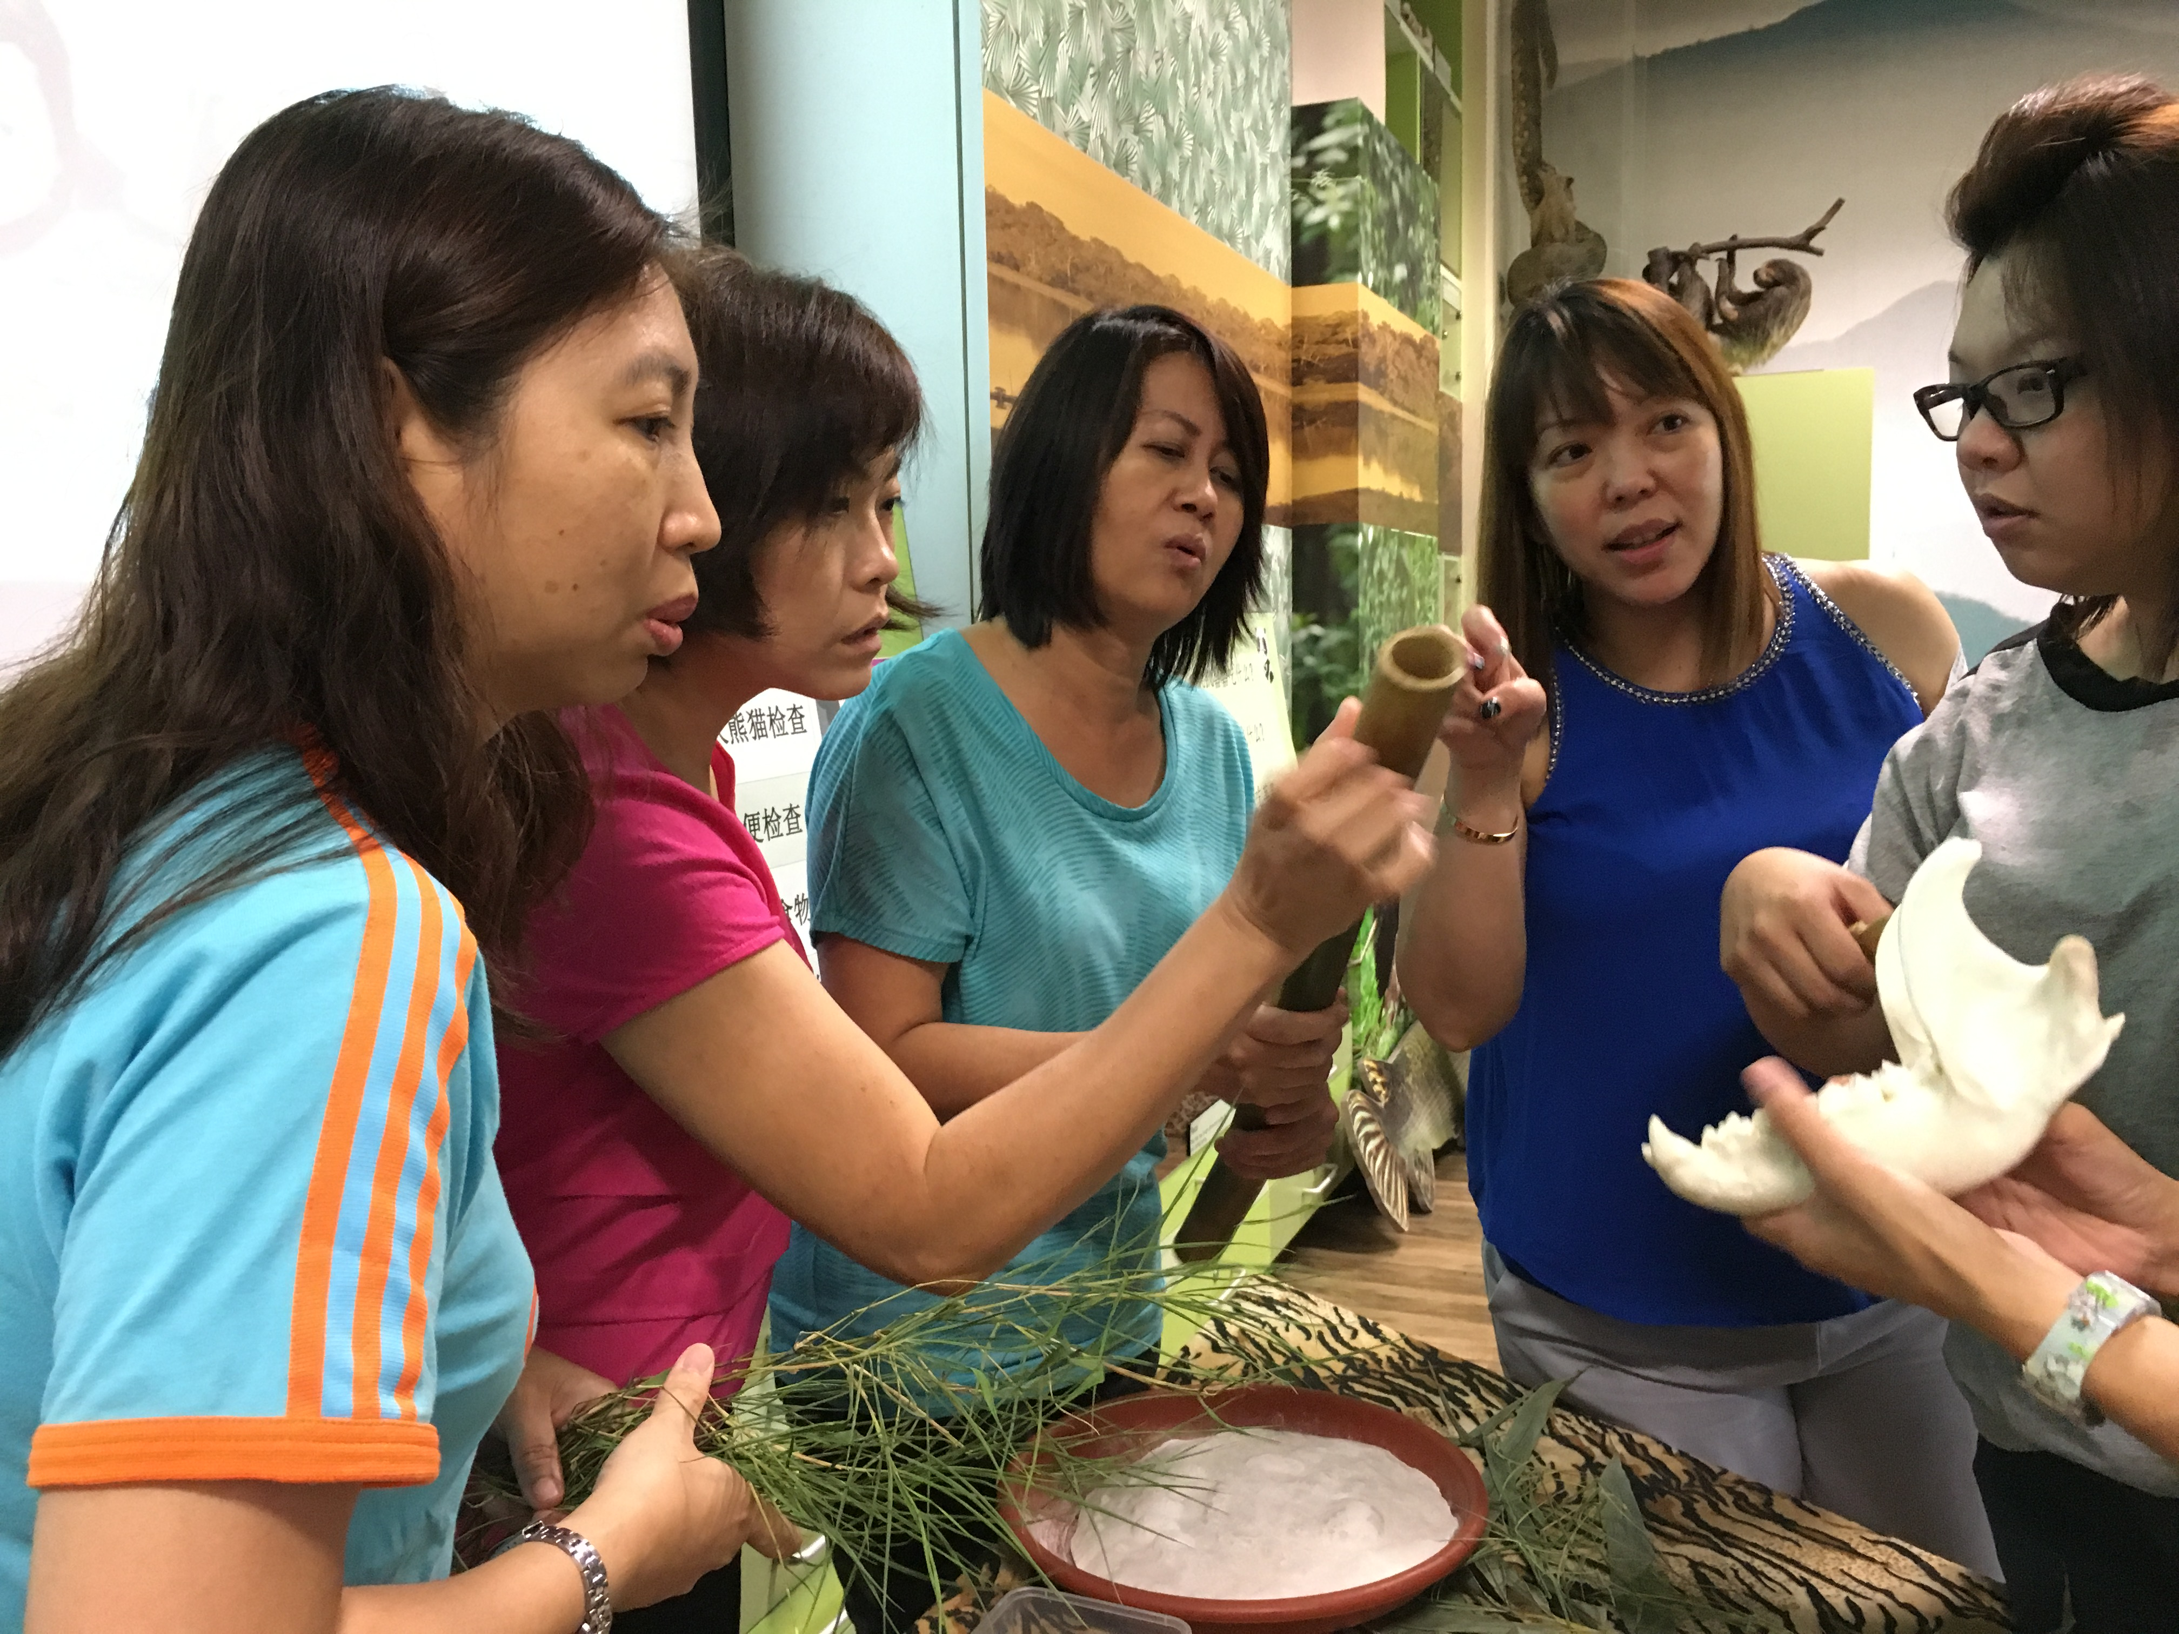

2018 娃娃游园乐 Wow Wild Learn (2018)
河川生态园教师培训Teacher Training Workshop

河川生态园 River Safari

时间 Time | 项目  Programme
0845 | 登记时间  Registration
0900 | 如何让华文学习在河川生态园“动”起来  How to make learning Chinese interesting in River Safari
- 介绍河川生态园
About River Safari
- 《我是熊猫饲养员》小话剧
“I’m a Panda Keeper” in-park programme
- 介绍大熊猫辅助读物
Giant Panda Supplementary Readers for Pre-schoolers
0950 | 茶点时间  Tea-break
1010 | 如何带领学生在河川生态园进行学习之旅  How to plan a Learning Journey in River Safari
 | - 游园须知
 | - 看、说、做什么？
1300 | 午餐时间  Lunch
1345 | 小组讨论：如何设计河川生态园学习之旅教案  Group discussion: Designing a lesson plan for learning journey to River Safari
1445 | 分享与讨论各组教案  Sharing and Discussion of lesson plans
1545 | 如何上网订票、预订小话剧及订购读物  How to order tickets, purchase supplementary readers and book programmes online
1630 | 反馈时间  Feedback
1700 | 培训结束  End of session

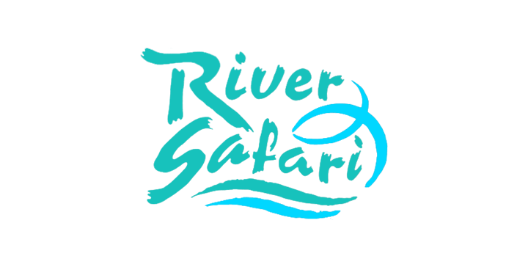
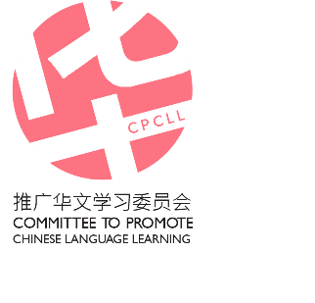

Information Sheet 3
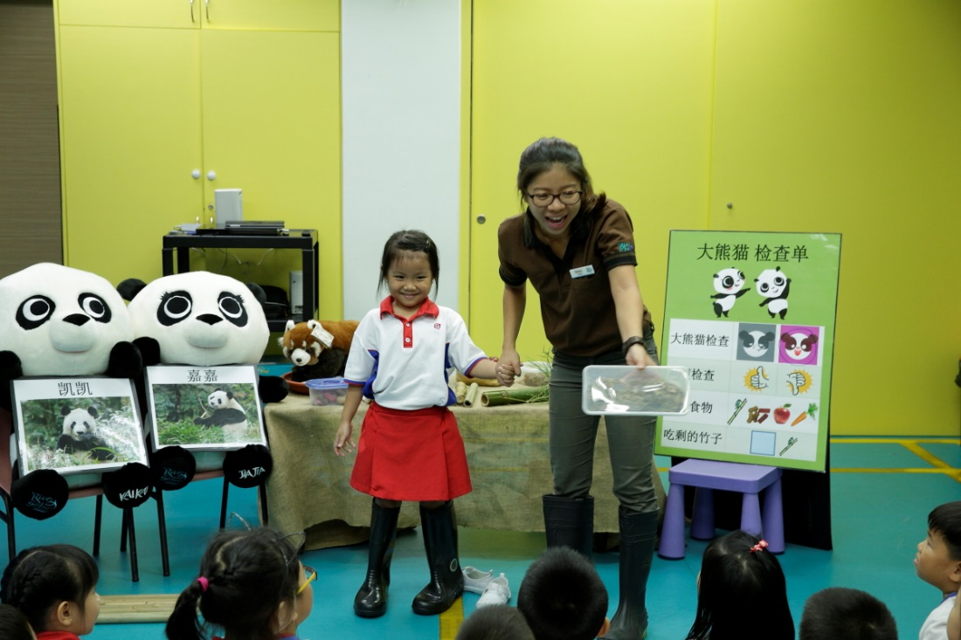

《我是熊猫饲养员》小话剧
“I’m a Panda Keeper” in-park programme

大熊猫凯凯和嘉嘉最爱吃什么？它们每天会吃多少竹子？熊猫饲养员Keeper Splash将与学生分享他每天如何细心照顾凯凯和嘉嘉的饮食与健康。幼儿还能参与其中，当个小小饲养员，协助Keeper Splash观察大熊猫是否生病了。

What do our Giant Pandas, Kai Kai and Jia Jia, like to eat? How much bamboo do they eat in a day? Let Keeper Splash share how he ensures a good diet for our Giant Pandas. Pre-schoolers will also be invited to participate and assist Keeper Splash in his daily checks of the pandas.

